Introducing Uncertainty Quantification to Techno-economic Models of Manufacturing Field-Grown Plant-Made Products
Matthew J. McNulty^{1,#} and Kirolos Kelada^{1,#}, Debashis Paul², Somen Nandi^{1,3}, and Karen A. McDonald^{1,3,*}
¹ Department of Chemical Engineering, University of California, Davis, CA, USA
² Department of Statistics, University of California, Davis, CA, USA
³ Global HealthShare Initiative, University of California, Davis, CA, USA

#These authors contributed equally for this manuscript and are considered as co-first authors

* Corresponding author, Email: kamcdonald@ucdavis.edu, Phone: +1 (530) 752-8314

Abstract
There is a growing demand for large market natural and biotechnological products, for example, consumer preferences drive plant-based meat alternatives, health risks of sugar overconsumption continue to motivate alternative sweeteners, and the COVID-19 pandemic has reinvigorated interest in countries developing in-house vaccine and medication production capabilities. The current paradigm of bioreactor-based biomanufacturing faces difficulties of scalability and a high entry barrier of capital intensity and workforce specialization. Field-grown plant-based manufacturing, as an inexpensive and readily scalable platform, is a promising strategy to meet this emerging demand. Despite some successes in field-grown bioproducts manufacturing by companies such as Ventria Biosciences, concerns of product variability have largely stymied growth in this area. Here we report on the development and use of techno-economic modeling coupled with Monte Carlo-based uncertainty quantification as an effective tool to quantify and mitigate the impact of crop variation on product quality and supply for field-grown plant-based manufacturing.
Keywords
Plant molecular farming, plant-based manufacturing, uncertainty quantification, process simulation tool, techno-economic analysis, agricultural production
Abbreviations
CAPEX, capital expenditures; CEX, cation exchange chromatography; COGS, cost of goods sold; IRR, internal rate of return; OPEX, operating expenditures; P&F, plate and frame; QA, quality assurance; QC, quality control; UF/DF, ultrafiltration/diafiltration; USDA, U.S. Department of Agriculture; VBA, Visual Basic for Applications.
1. Introduction
Recent times have brought to the forefront of attention the need for large and reliable source of medication and other biologically-derived products. In these times, world leaders are more concerned than ever with the global biotechnology manufacturing capability. Current manufacturing strategies often depend on bioreactors that require complex equipment infrastructure, large time and capital investments to construct them, and a highly trained specialized workforce to operate them. The ability of this current biotechnology manufacturing paradigm to scale to meet projected global needs across the breath of medical, agricultural, and industrial products is yet unproven. Biotechnology, as a set of emerging industries within which is contained high-profit margin of production, has been traditionally averse to manufacturing platform risks for established product categories such as biopharmaceuticals. This in turn generates vulnerabilities as one considers projections of demand for biologically-derived products, such as biopolymers (Van Beilen and Poirier, 2008), plant-based protein (Ismail et al., 2020) and oils (Kojima et al., 2016), natural sugar alternatives (Sylvetsky and Rother, 2016), and biopharmaceuticals (Kesik-Brodacka, 2018), increasing several orders of magnitude while sometimes also demanding several orders of magnitude shorter product cycle time. In a recent perspective, we highlighted these vulnerabilities and proposed one solution of how to tackle both the immediate need to address COVID-19 diagnostic reagent shortages and crop surpluses using plant molecular farming (McDonald and Holtz, 2020).
Plant molecular farming, the production of high-value natural or recombinant products in plants, has been heralded as an accessible platform for expanding manufacturing globalization with lower infrastructure costs and workforce specialization than traditional bioreactor-based systems (Ma et al., 2003). Stainless steel bioreactors with advanced control systems for a suite of online process variables are replaced by plants, within which a portion of the control systems are absorbed by the natural supracellular regulation systems.
The most advanced efforts in commercialization of molecular farming currently utilize advanced infrastructure, controlled environment facilities containing artificial lighting, controlled atmospheric composition and flow rate, and hydroponic systems to produce recombinant products with demands of 10’s to 1,000’s of kilograms per year (Holtz et al., 2015). However, even the complexity and cost of indoor plant cultivation may be prohibitive to broaching larger market products and generally meeting a growing global need across different biotechnological product classes.
Molecular farming of recombinant products in an outdoor agricultural field setting has been an alluring and aspirational target for as long as molecular farming has been an area of research. Despite some early successes with companies like Large Scale Biology Corporation (Pogue et al., 2002), and continued successes of companies like Ventria Biosciences (Chen et al., 2018; Laffan et al., 2011; Nandi et al., 2005), molecular farming of recombinant products in an outdoor agricultural field setting has faced setbacks including regulatory backlash from Prodigene’s pharmaceutical crop mishandling (Kermode and Jiang, 2018) and from mixed public perception, in part as it is lumped with genetically modified food crops (Ma et al., 2005). It is prudent to note that the regulation of transgenic crops outdoors has matured significantly, as exemplified by the clear language in the U.S. Department of Agriculture (USDA) Animal and Plant Health Inspection Service Biotechnology Regulatory Services and comfort of the agency to drop requirements for annual USDA permit renewal in some cases where the transgenic lines are declared safe after years of evaluation. Recent publications on molecular farming in an outdoor agricultural field setting highlight the significance of the pitfalls, but also detail a path forward into commercial success driven by the low cost, production scale, and accessibility (Ma et al., 2013; McDonald and Holtz, 2020; McNulty et al., 2020).
Perhaps the largest blocker to development of outdoor molecular farming is the crop variation, both intra- and inter-batch, that arises from exposure to natural soil and climate variation and is perceived as a concern for consistency of product critical quality attributes (Moustafa et al., 2016). If concerns of product consistency are alleviated, it is likely that there will be a subsequent need to also address the intertwined concern of crop yield fluctuation (Iizumi and Ramankutty, 2016).
In manufacturing products, such as commodity goods, for which ensuring consistent supply can be critical, the evaluation of risks associated with meeting target throughput and variation in product cost of manufacturing should be evaluated and communicated to stakeholders to complement the decision-making process when assessing the feasibility of processes under uncertainty and strategic planning.
All biomanufacturing introduces a degree of variation in the production. There is a myriad of external factors that can influence production rate and product quality. For example, consider that in biopharmaceutical production, where the product attributes are highly controlled to ensure efficacy and safety to the patient, there are some raw material changes (e.g., source of certain culture media components) can be made by the vendor without the biopharmaceutical manufacturer being notified. Manufacturers and regulators understand the potential variation, and the product is validated with process and product ranges to accommodate this uncertainty. Outdoor plant molecular farming is no different in this respect, but there are concerns that the magnitude or unpredictability of variation is greater than can be absorbed by either downstream processing or a given threshold of an attribute within the quality target product profile. However, to our knowledge, there has not been in-depth evaluation of crop variation that quantifies and propagates the impact to key performance metrics such as cost of goods sold, facility throughput, and product critical quality attributes (e.g., product purity).
Earlier studies have established the concept of uncertainty quantification using techno-economic models to capture production variation of biomanufacturing processes. These investigations have focused primarily on biofuel (Batan et al., 2016; J. Zhuang et al., 2007) and biopharmaceutical (Martagan et al., 2018; Papavasileiou et al., 2007) production systems with limitations of coarse techno-economic models and/or limited uncertainty quantification analyses. Notably rigorous, the uncertainty analysis of penicillin V production using fermentation processes includes a detailed model and robust inclusion of uncertainty parameters (Biwer et al., 2005). However, this report does lack scenario analysis and optimization under uncertainty, both of which are important methodology considerations for plant molecular farming-based manufacturing.
Kelada and coauthors recently published the first techno-economic analysis of plant molecular farming to manufacture a target commodity product at a rate of 50,000 kg per year (Kelada et al., 2020). In this analysis, the authors simulate a larger production-scale facility than has been commercially realized to date to provide perspective on the feasibility and benefits of plant molecular farming for large demand products. The findings indicate that outdoor field cultivation is one manufacturing strategy to reduce costs compared with the traditional indoor cultivation to meet the price points of commodity and industrial products. In the work by Kelada and in all other molecular farming techno-economic studies to date, a fixed and constant production rate is assumed in designing and sizing the facility.
Other molecular farming techno-economic studies have explored technical and economic viability of primarily indoor production of monoclonal antibodies (Nandi et al., 2016), antiviral proteins (Alam et al., 2018), biodefense agents (Tusé et al., 2014), and antimicrobial proteins (McNulty et al., 2020), although the latter two studies did compare indoor growth to outdoor field growth scenarios but at much smaller production scales.
Here we present an introductory investigation into uncertainty quantification in outdoor field-grown plant-made products. We use Monte Carlo-based simulation to augment a techno-economic model of an ultra-large-scale manufacturing facility producing 50 MT per year of 98% pure commodity product. The primary objective of this work is to present a foundational tool for quantifying uncertainty to reduce stakeholder concerns and to optimize outdoor field-grown plant molecular farming facilities.

2. Materials and Methods
  - Process simulation
This work builds on our recently published techno-economic model of ultra-large-scale field-grown production of the recombinant sweetener, thaumatin II, in ethanol-inducible transgenic Nicotiana tabacum using a process simulation tool, SuperPro Designer® version 10 build 7 (Intelligen, Inc.), and Microsoft Excel-based calculations. The published model, as well as the modified model used for this work, is publicly available at http://mcdonald-nandi.ech.ucdavis.edu/tools/techno-economics/. A free trial version of SuperPro Designer (http://www.intelligen.com/demo.html) can be used to view the model and run the simulation. The previously published model has been generalized for the production of high-value recombinant proteins, the upstream and downstream processing process flowsheets have been merged, and the process scheduling is defined by rated throughput of the equipment when applicable (Figure 1). The generalized model can be readily adapted for production of natural protein products by omission of the tractor spraying procedure, which serves as the induction of ethanol-inducible transgenic production.
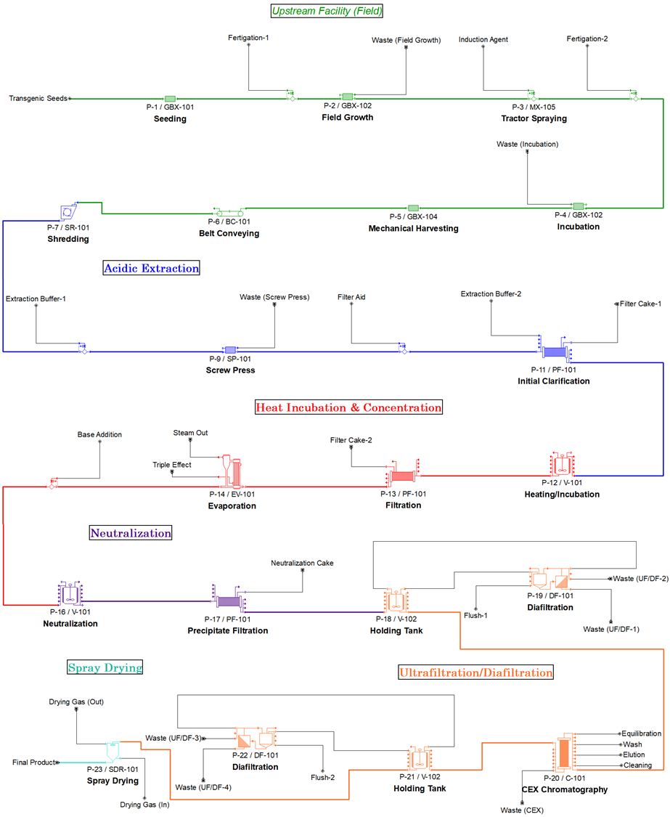
Figure 1. Process flowsheet for the field-grown production of recombinant proteins in Nicotiana tabacum in the SuperPro Designer® model. Process flowsheet has been adapted from the work of Kelada et al. 2020 (Kelada et al., 2020).

Our previous work did not include profitability analysis. For this analysis, we selected three selling prices of $1,138/kg, $2,275/kg (base case), and $4,225/kg based the cost of goods sold of our previously reported base case techno-economic model ($591/kg, without depreciation) and on previously reported average of gross margins from 1994 to 2005 for an aggregate of companies qualified as generic pharmaceuticals (48%), brand-name pharmaceuticals (74%), and biotechnology (86%) (Basu et al., 2008). Lower gross margins, as are typical for other relevant sectors (agriculture (11%); food processing (26%); specialty chemicals (31%)), have also been considered in the analysis (retrieved from New York University’s Stern School of Business; http://pages.stern.nyu.edu/~adamodar/ New_Home_Page/datafile/margin.html).

  - Uncertainty quantification
We combine Monte Carlo-based stochastic simulation analysis using Oracle® Crystal Ball with deterministic techno-economic process simulation in SuperPro Designer. We have written custom Visual Basic for Applications (VBA) scripts in Microsoft Excel to interact with SuperPro Designer using SuperPro Designer’s built-in Component Object Module library, which is expressly designed for this purpose. The Crystal Ball plug-in to Microsoft Excel generates stochastic input parameter values based on a pre-determined probability distribution and the VBA script then sets the SuperPro Designer facility model performance accordingly and records the results of selected forecast variables (e.g., cost of goods sold, annual throughput).
The facility model equipment is sized for maximal equipment utilization according to the static average base case values. As such, equipment throughput and capacity are exceeded for input parameter values that result in higher stream volume or product mass than the base case model. In these instances, SuperPro Designer triggers a warning or error notification, but regardless still sends the full process stream (including any capacity exceeding that of the equipment) to the next unit operation by default. We implemented a simple Microsoft Excel-based algorithm to correct the facility model in these cases. For exceeded stream volume capacity, biomass from field growth yield, which dictates stream volume, is reduced from the stochastically determined value to a value corresponding to the “effective” field growth yield, defined as the maximal yield that the facility can process based on equipment capacity. Physically, this is designed to be representative of plowing excess biomass back into the fields for soil enrichment. For exceeded product mass capacity, as only chromatography performance is assumed to be sensitive to this value, it is assumed that there will be negligible impact to chromatography binding capacity and that excess will be diverted to the flow-through, resulting in a reduction of the stochastically determined cation exchange chromatography (CEX) recovery of product value to a value corresponding to the “effective” CEX recovery of product, defined as the maximal recovery that the resin binding capacity can accommodate.
One known disadvantage of Monte Carlo-based simulation is the high trial number needed to closely approximate the distributions. We chose to run each uncertainty analysis for 20,000 trials. Profitability-related forecast variables include 20,000 trials for each plot, while process-related variables include 60,000 trials (combined 20,000 trials for each of the three selling prices analyzed for profitability-related forecasts). Each trial returns the facility forecast variables values calculated for a full facility lifetime of 25 years. For process performance forecast variables, each trial can also be interpreted on a batch-basis, while profitability forecast variables would need to be calculated differently for a batch-basis interpretation, rather than facility lifetime, of trial results. We were able to run each set of 20,000 trials of combined stochastic-deterministic evaluation on a personal computing machine on the order of several hours running time.

  - Input parameter uncertainty
We selected a set of input parameters for uncertainty analysis (Table 1). Input parameters were screened and selected on the basis of known uncertainty, techno-economic impact, and relevance to outdoor field growth. Supporting information for determination of the input parameter probability distributions, and graphical depictions of these distributions, are included in Supplementary Information (S1. Assessment of assumption distributions; S2. Assumption distributions & trial data). Probability distributions are defined such that the mean is equal to the static value assigned in the base case model.
Variable | Procedure | Base Case Value | Distribution | Variation [Range]
Field growth yield  (% maximal*/100)  *132 g FW/plant | P-2 | 0.76 | scaled beta | alpha = 2.57, beta = 4.80  [0.63, 1.0]
Field growth time  (days) | P-2 | 34.83 | triangular | likeliest = 34.83, ± 5% likeliest  [33.09, 36.57]
Expression level  (g product/kg FW) | P-4 | 1.5 | logistic | mean = 1.5, scale = 0.08  [0.95. 2.05]
Harvesting time  (hours) | P-5 | 8 | scaled beta | alpha = 1, beta = 8  [4, 40]
P&F filtration removal  (% product lost) | P-11 | 5.15 | normal | mean = 5.15, SD = 0.52  [3.55, 6.75]
P&F filtration removal  (% impurities removed) | P-11 | 5.15 | normal | mean = 5.15, SD = 0.52  [3.55, 6.75]
P&F filtration flux (L/m²∙h) | P-11 | 180 | triangular | likeliest = 180, ± 20% likeliest  [144, 216]
P&F filtration removal  (% product lost) | P-13 | 5.43 | normal | mean = 5.43, SD = 0.54  [3.75, 7.11]
P&F filtration removal  (% impurities removed) | P-13 | 95.0 | normal | mean = 95.0, SD = 0.54  [93.32, 96.68]
P&F filtration flux (L/m²∙h) | P-13 | 200 | triangular | likeliest = 200, ± 20% likeliest  [160, 240]
P&F filtration removal of product  (% product lost) | P-17 | 1.72 | normal | mean = 1.72, SD = 0.17  [1.08, 2.26]
P&F filtration removal of impurities  (% impurities removed) | P-17 | 1.72 | normal | mean = 1.72, SD = 0.17  [1.08, 2.26]
P&F filtration flux (L/m²∙h) | P-17 | 30 | triangular | likeliest = 30, ± 20% likeliest  [24, 36]
UF/DF filtration flux (L/m²∙h) | P-19 | 30 | triangular | likeliest = 30, ± 20% likeliest  [24, 36]
CEX recovery  (% product recovered) | P-20 | 88.5 | triangular | ± 10% base case  [80, 97]
CEX recovery  (% impurities recovered) | P-20 | 5.0 | triangular | ± 10% base case  [4.5, 5.5]
UF/DF filtration flux (L/m²∙h) | P-22 | 40 | triangular | likeliest = 40, ± 20% likeliest  [32, 48]
Table 1. Input parameters selected for uncertainty quantification and the defined probability distributions. FW, fresh weight; P&F, plate and frame; UF/DF, ultrafiltration/diafiltration.

2.3 Input parameter correlations
Input parameter values are by default generated independent of each other using random selection from the given probability distribution. However, parameter-parameter interactions and correlations are to be expected during manufacturing. We consider several parameter correlations in the uncertainty quantification analysis by defining Pearson correlation coefficients in Crystal Ball to establish a degree of linear relationship between two variables. The Pearson correlation coefficients used in the model are primarily based on the reported findings in Knödler and colleagues (Knödler et al., 2019). We also assume on the basis of working process knowledge that there is a moderate positive correlation (r = 0.7) between product loss and impurities removal in the plate and frame filtration procedure P-11.
 | Field growth yield  (P-2) | Field growth time  (P-2) | Expression level  (P-4) | P&F removal of product  (P-11) | P&F removal of impurities (P-11) | CEX recovery of product  (P-20)
Field growth yield  (P-2) | -- | r = 0.8842 |  | r = -0.6321
Field growth time  (P-2) | r = 0.8842 | --
Expression level  (P-4) |  |  | -- |  |  | r = 0.6042
P&F removal of product  (P-11) |  | r = -0.6321 |  | -- | r = 0.7 | r = 0.9432
P&F removal of impurities (P-11) |  |  |  | r = 0.7 | --
CEX recovery of product  (P-20) |  |  | r = 0.6042 | r = 0.9432 |  | --
Table 2. Pearson correlation coefficients

2.4 Forecast variable selection
We selected a set of forecast variables to capture the value in uncertainty quantification as a tool to identify parameters that are likely to impact the bottom line and to optimize field-grown plant-made product facilities. Table 3 provides a list of all forecast variables measured in the uncertainty quantification analysis. The cost of goods sold (COGS) forecast variable is calculated with depreciation included.
Forecast Variable | Justification | Desired Output
Internal rate of return, after tax  (% discount rate) | Represents a measure of the project profitability based on future cash flows in present dollar value, while taking in consideration the initial investment, operating costs, revenues, and taxes. | ≥ 30%
Cost of goods sold  ($/kg product) | Represents the production cost and serves as a key determinant of profitability. | ≤ $850/kg product
Annual throughput  (kg product/year) | Represents the product supply and can inform supply chain management and market penetration strategies. | ≥ 4.0 x 10⁴ kg/year  ≤ 6.5 x 10⁴ kg/year
Product purity  (% purity) | Represents the product quality and can inform manufacturing strategies to ensure standards for the product critical quality attributes are met. | ≥ 97.5%
Table 3. The selected forecast variables, a brief justification of their inclusion/significance, and hypothesized desired output ranges are included for the sake of illustrating richness of analysis capabilities.

2.5 Sensitivity Analysis
Sensitivity analysis is generated by Crystal Ball for each forecast variable using simulation run data. A rank correlation coefficient is calculated between every forecast and assumption. Percent contribution to variance is calculated from the rank correlation coefficient. Correlation among the input parameters was not included while considering the Monte Carlo-based simulations runs for sensitivity analysis.

3. Results
3.1 Uncertainty quantification
Individual forecast variable uncertainty quantification is shown by histogram, cumulative probability distribution, and top input parameter contributions to variance in Figure 2. Expression level (P-4), field growth yield (P-2), field growth time (P-2), P&F removal of product (P-13), and CEX recovery of product (P-20) have been generally identified as top contributors to variance for the selected set of forecast variables analyzed. Additional information on the forecast variable outputs, including graphical assessment of normality and a list of contributions to variance for all input parameters, is included in Supplementary Information (S4. Forecast contributions to variance; S6. Forecast variable normality).
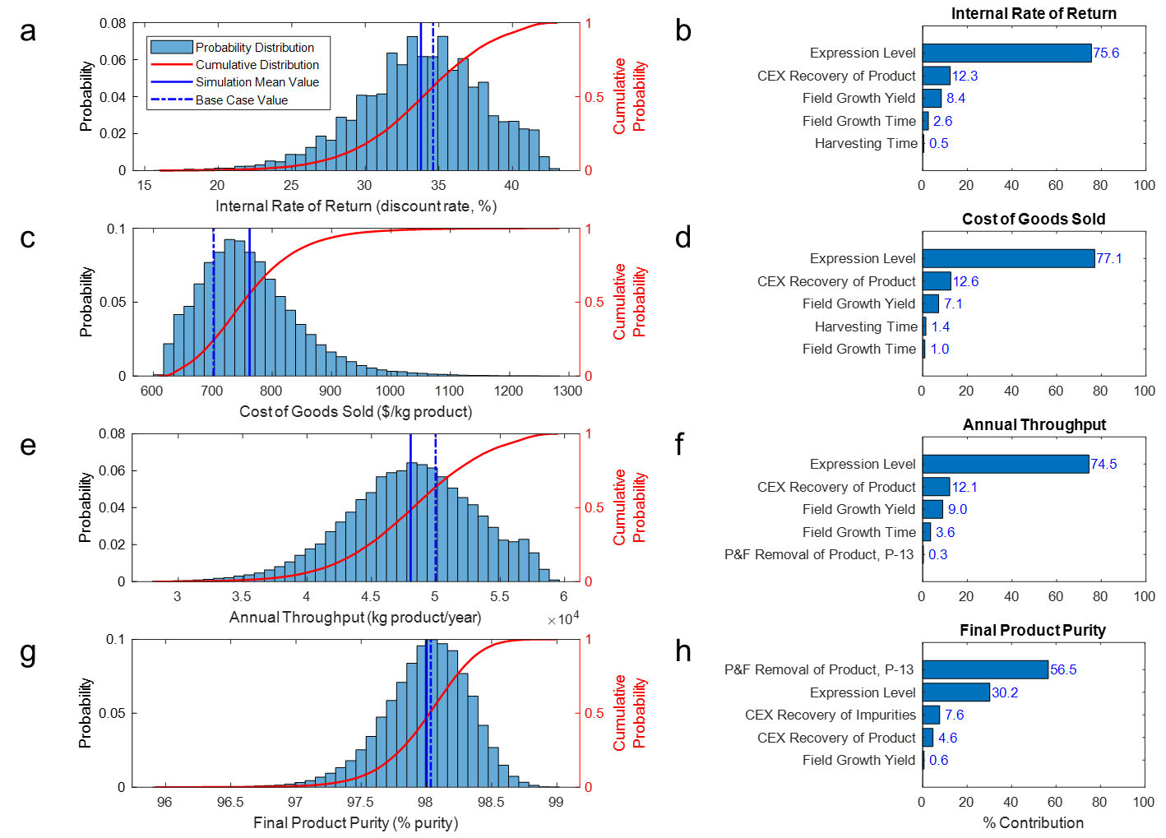
Figure 2. Probability distributions and top five assumption contributions to forecast variance for internal rate of return (a, b), cost of goods sold (c, d), annual throughput (e, f), and final product purity (g, h).

Relationships between the forecast variables are shown in Figure 3, highlighting the interplay between the process performance and profitability forecast variables. As can be generally expected, high Annual Throughput and low COGS are associated with high internal rate of return (IRR). The density plots (Figure 3, E-H) show a negative skewness for all three process performance forecast variables. Based on the desired forecast target ranges listed in Table 3, we project the manufacturing, as given by the model simulation, meeting desired COGS output specifications with 86.5% certainty (17,299/20,000 trials), annual throughput with 93.7% certainty (18,747/20,000 trials), product purity with 92.6% certainty (18,529/20,000 trials), IRR with 82.5% certainty (16,490/20,000 trials), and meeting all four output specifications with 80.8% certainty (16,161/20,000 trials).
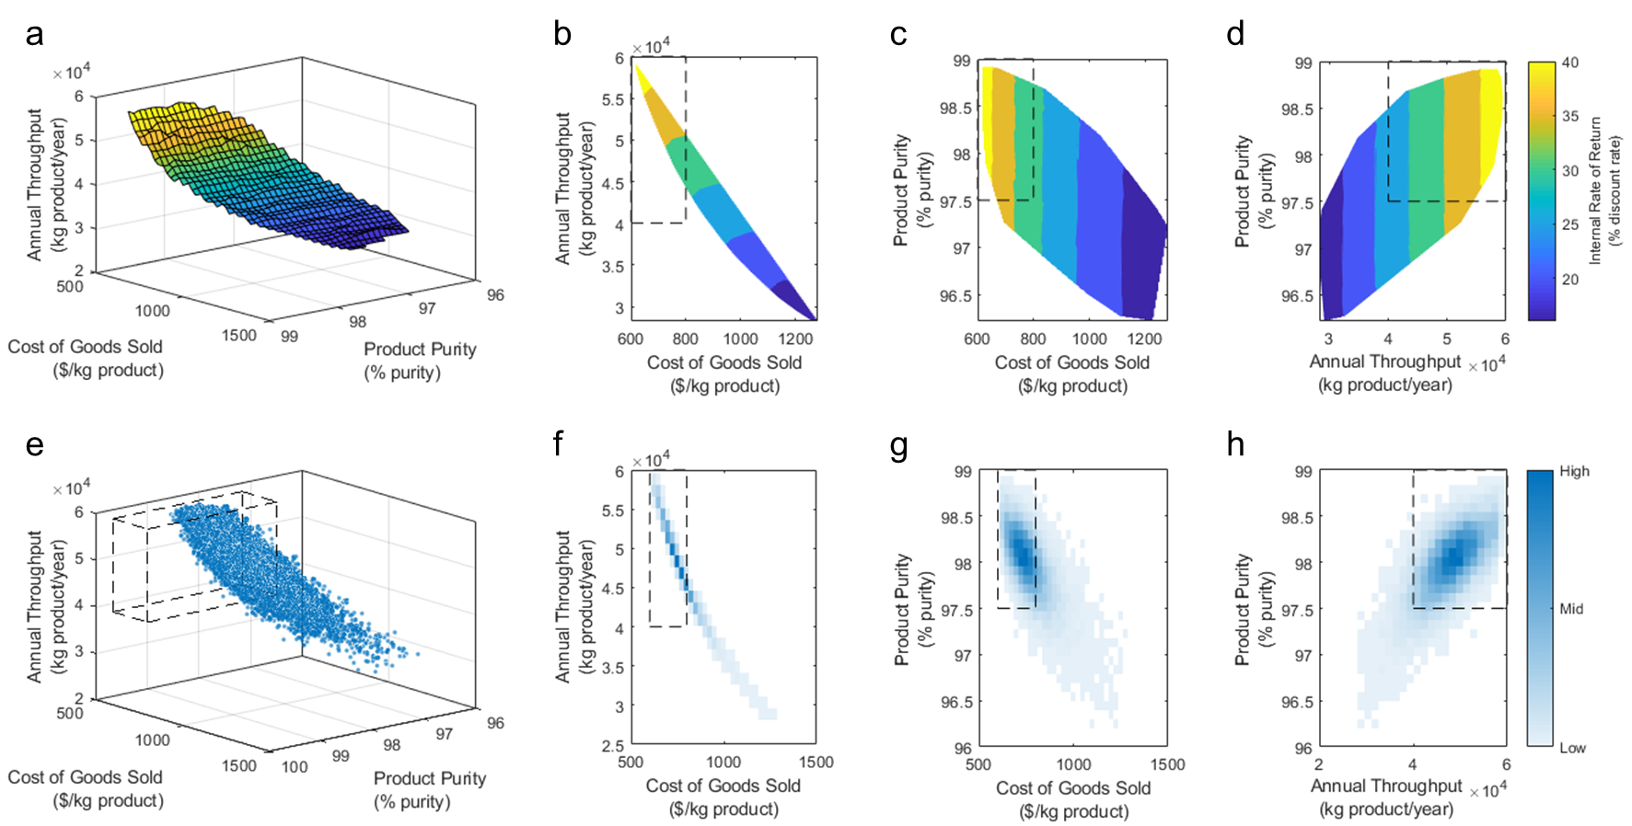
Figure 3. Relationship between the forecast parameter outputs as a function of internal rate of return and data density. Contour plots display overall and pairwise relationships (A – D). A 3D-scatter plot displays the overall relationship (E) and binned scattered plots display pairwise relationships (F – H).

3.2 Facility oversizing
The equipment of the base case facility model is sized to maximize equipment utilization for the nominal static average input parameters. Here we investigate the impact of oversizing equipment (base case = 0% oversize) to reduce or eliminate probability of process stream waste for above average throughput trials on techno-economics. A facility model with 100% oversizing is defined as a scenario with equipment sized to process the maximum stream volume possible within the selected input parameter ranges. Simulations were performed at 0% (base case), 25%, 50%, 75%, and 100% oversizing. The following equipment were re-sized for this analysis: heat tank (V-101), evaporator (EV-101), tangential flow filtration hold tank (V-102), CEX column (C-101) (S5. Equipment oversizing specifications). All other equipment were capable of processing the maximum stream volume without re-sizing using a rated throughput.
Simulation trials in which the equipment capacity is exceeded operate according to what we are terming as effective assumptions. The effective assumption is the defined assumption probability distribution constrained by the equipment capacity, as described in the Materials & Methods section. An effective assumption constrained by equipment capacity is observed for field growth yield and CEX recovery of product, as shown in Figure 4. There is a pronounced difference between the effective field growth yield and the governing field growth yield probability distributions under the 0% and 25% equipment oversize scenarios, the differences being statistically significant from all other equipment oversize scenarios. The hypotheses being tested here are about the equality of the means of the two probability distributions, and the tests used are the standard two-sample t-tests with two-sided alternatives, at level of significance α = 0.05. Means of these two probability distributions under 50%, 75%, and 100% oversizing scenarios were not statistically different. Subsequent statistical evaluation of the probability distributions of these scenarios illustrated that the 50% scenario output is not borne of an equal distribution to that of the 75% and 100% oversizing scenarios (tests for equality of pairs of probability distributions are performed using the two-sample Kolmogorov-Smirnov test, at significance level α = 0.05). The difference between the mean effective CEX recovery of product for the 0% oversizing scenario and all other scenarios is statistically significant. Means, and more generally, the distributions, under the 25%, 50%, 75%, and 100% oversizing scenarios were not statistically different. Additional details of the two-sample statistical analyses are included in Supplementary Information (S7. Two-sample t-tests for means; S8. Kolmogorv-Smirnov tests for distributions).
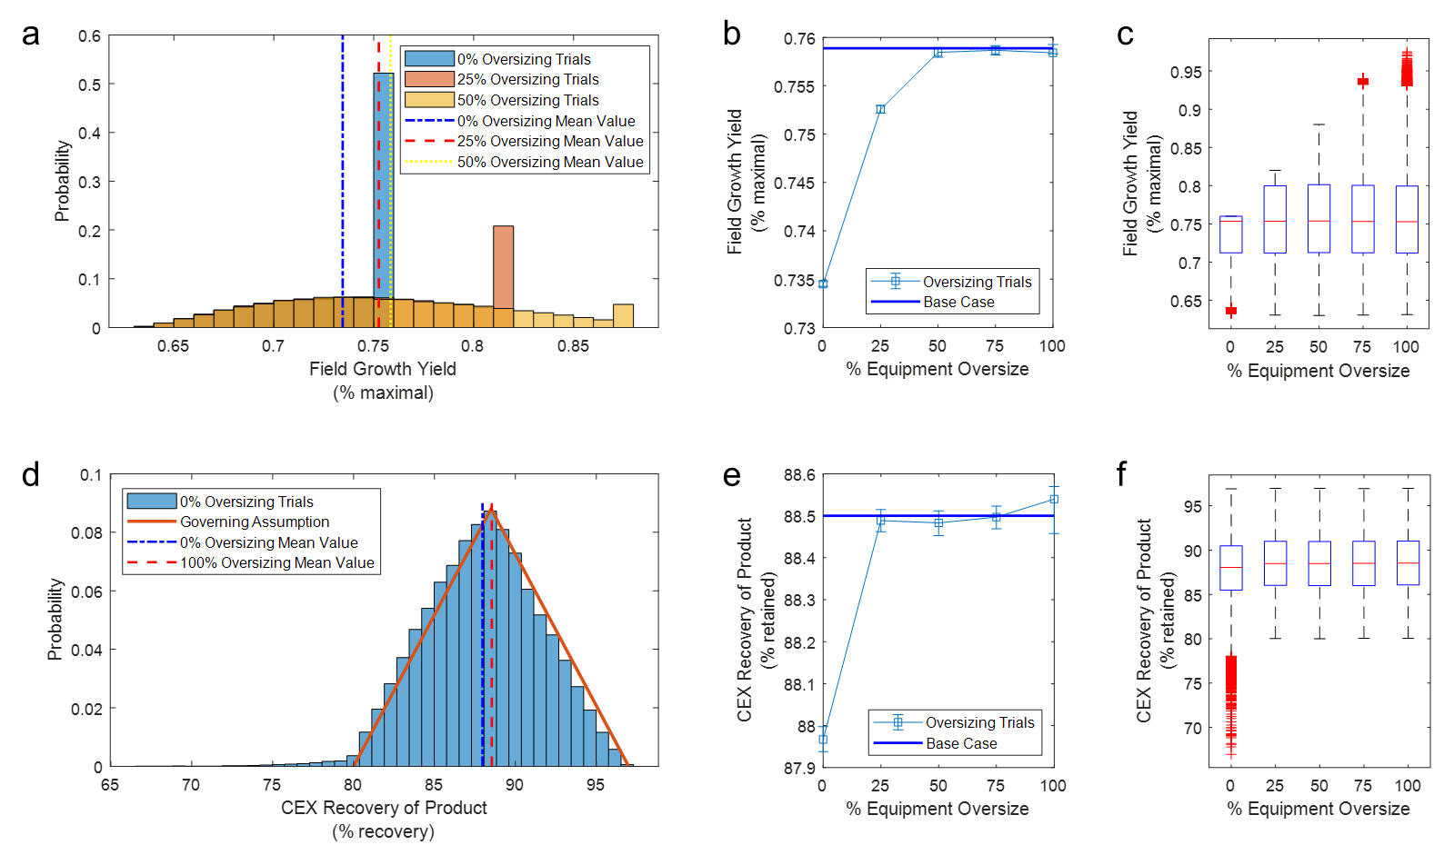
Figure 4. Impact on input variables due to extent of equipment oversizing is displayed using histograms, scatter plots of the mean simulation values, and box plots for field growth yield (a, b, c) and CEX recovery of product (d, e, f). Error bars represent the 95% confidence interval of the mean.

Individual forecast variable uncertainty quantification is shown across the equipment oversize scenarios by histogram and scatter plots of the mean values in Figure 5. The profitability of the facility model, as given by IRR, is inversely related to extent of equipment oversizing. The mean IRR values for the different scenarios are significantly different. We postulate that this can be largely explained by the monotonically increasing mean value of COGS (the mean COGS value for each scenario is also statistically distinct). The mean value of annual throughput also increases with extent of equipment oversizing up until 50% oversizing, whereupon additional oversizing does not contribute a statistically significant difference in the mean (or distribution) of throughput. For perspective on the relative cost of increased throughput for these scenarios, consider that the mean value of the 100% equipment oversizing scenario results in 3.85% greater annual throughput and 21.4% greater COGS than the 0% scenario values. In contrast, product purity is more comparable across scenarios; only in the 0% oversizing scenario, the mean and the distribution of purity are statistically distinct from those in the other scenarios.
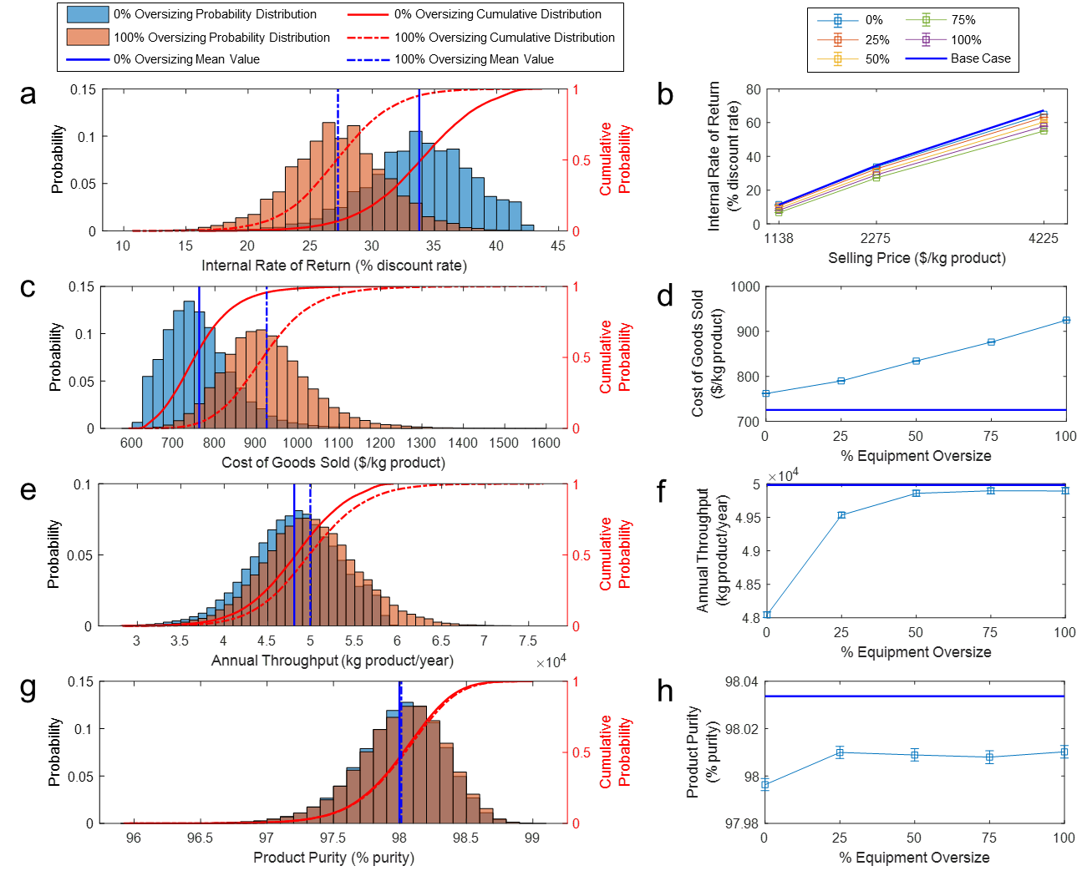
Figure 5. Impact on forecast variables due to extent of equipment oversizing is displayed using histograms and scatter plots of the mean simulation values for internal rate of return after tax (a, b), annual throughput (c, d), cost of goods sold (e, f), and product purity (g, h). Error bars represent the 95% confidence interval of the mean.

A comparison of cost breakdowns for the equipment oversizing scenarios is shown in Figure 6. Consumables are the most sensitive cost items to the extent of equipment oversizing, increasing the relative contribution to operating expenditures (OPEX) by ~20% from the 0% to 100% oversizing scenario. The UF/DF process section is the most sensitive to extent of equipment oversizing, increasing relative contribution to OPEX by ~15% from the 0% to 100% oversizing scenario. This is primarily due to the contribution of the CEX procedure. The ratio of upstream-to-downstream OPEX generally decreases with extent of equipment oversizing, while the capital intensity, the ratio of OPEX to capital expenditures (CAPEX), generally increases. This is consistent with the generally accepted notion that downstream processing is higher capital intensity than upstream processing.
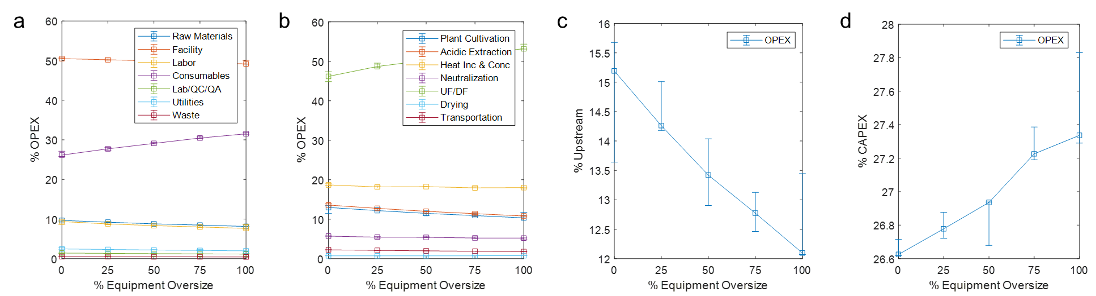
Figure 6. A comparison of cost breakdowns and equipment oversizing of the facility for the mean simulation values shown by (a) cost item, (b) process section, (c) total upstream contribution, and (d) the ratio between operating and capital expenditures. Data points represent the cost breakdowns of the simulation trials with the mean internal rate of return, while error bars represent those of the minimum and maximum internal rate of return. QC, quality control; QA, quality assurance; UF/DF, ultrafiltration/diafiltration; OPEX, operating expenditures; CAPEX, capital expenditure.s

3.3. Optimization scenario: chromatography retrofit
Here, we demonstrate how the process simulation model representing an existing facility can be used to aid in a retrofitting process. We suppose that the facility, represented by the base case scenario (0% oversizing), is fixed and fully constructed except for the CEX chromatography step, which is anticipated to be added to the floor as the facility manufacturing switches to a new target protein product. In this case, the process simulation model can be used to optimize the sizing of the CEX chromatography step in the context of the otherwise existing facility.
The base case scenario CEX column size, which was calculated using static average values, is used as the optimization starting point. We fixed the bed height and allow the CEX resin volume to vary with bed diameter for CEX size optimization. Oracle Crystal Ball’s OptQuest tool was used to determine the CEX diameter that maximizes the mean value IRR of simulations of 20,000 trials in the range of 0.7 – 1.7 m diameter (base case = 1.2 m) discretized in 0.01 m increments.
The results of the CEX optimization are show in Figure 7. The optimal value was determined to be a diameter of 1.2 m, which is consistent with the value in the base case scenario.
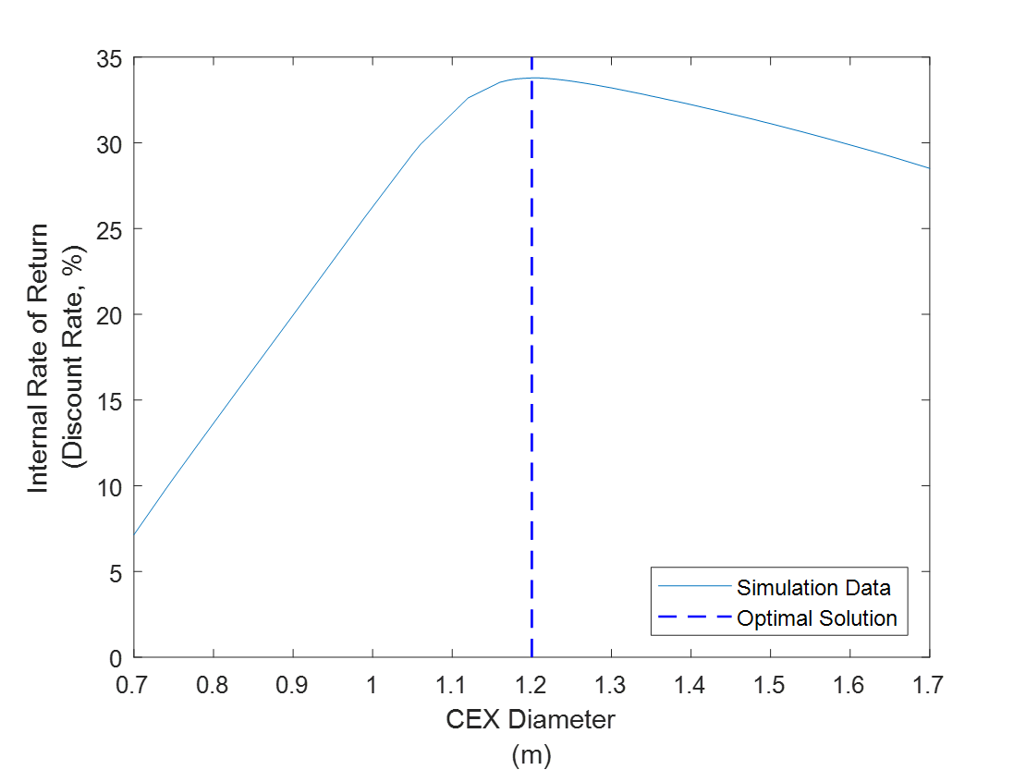
Figure 7. Uncertainty-based optimization of cation exchange chromatography sizing in the 0% oversize scenario set to maximize the mean internal rate of return given the assumed input parameter probability distributions. The mean internal rate of return is calculated using 20,000 simulation trials at each diameter value tested. Diameter range of 0.7 – 1.7 m is discretized in 0.01 m increments.

4. Discussion
The uncertainty quantification analysis of techno-economic process simulation in this work presents a range of potential technical and business insights that can be gained for production of natural and recombinant products in biotechnology manufacturing. In this work, we have specifically focused on field-grown plant molecular farming as a high-priority target to benefit from the quantification and management of uncertainty in driving commercial manufacturing. Field-grown molecular farming is a critical manufacturing platform for key commercial products including artemisinin for malaria treatment (Su and Miller, 2015), vinca alkaloids for multiple health indications including diabetes and cancer (Moudi et al., 2013), and stevia as a food sweetener (Singh et al., 2019), and provides distinct advantages in the future of biotechnological integration in a range of global markets. Addressing the uncertainty associated with plant-based production is one promising strategy to approach supply stabilization and to develop compelling plant-based manufacturing schemes.

4.1 Positioning plant molecular farming with outdoor field cultivation
A recent paper on scaling-up plant molecular farming does an excellent job in summarizing blockers and opportunities in the industry from the perspective of key stakeholders working on the Pharma-Factory project (https://pharmafactory.org) and the Newcotiana project (https://newcotiana.org) (Menary et al., 2020). Plant molecular farming has faced a slower technological maturation compared to traditional biotechnology manufacturing platforms. This has been attributed to a variety of factors – from being constrained to existing regulatory frameworks that are not amenable to assessing plant-based product manufacturing (Sparrow et al., 2013, 2007), to a lack of landscape-level pressures like policy driving sustainable manufacturing (Faye and Gomord, 2010), to being locked out of the market from past ventures whose failures are independent of the technology potential/value (Kermode and Jiang, 2018), to a lack of public acceptance of genetically modified crops (Pei and Schmidt, 2019). Plant molecular farming has responded to these factors by focusing on reducing public concerns, seeking niche-innovation, and establishing legitimacy through positive discourse. The industry is working to reduce public concern of contamination using non-food status crops (e.g., Nicotiana benthamiana) (Bally et al., 2018; Tremblay et al., 2010), manufacturing in indoor controlled environment facilities, and employing non-germline editing transient expression platforms (Holtz et al., 2015; Pogue et al., 2010; Spiegel et al., 2018). Niche-innovations with plant molecular farming to aid technological development outside of the normal market pressures focuses on spaces including orphan diseases, emergency treatments, and inexpensive vaccines (Kermode and Jiang, 2018). And finally, legitimation of plant molecular farming clusters around comparisons to traditional biotechnology manufacturing platforms that emphasize the safety advantages, low cost, sustainability or scalability (Buyel, 2018; Moustafa et al., 2016; Yao et al., 2015) and the opportunities for low- and middle-income countries with minimal existing pharmaceutical production capacity and expertise (Murad et al., 2020; Tsekoa et al., 2020).
These strategies have served well to move plant molecular farming towards technological maturation (Fischer and Buyel, 2020). However, the direction of plant molecular farming technological development borne of these strategies can appear to be at cross-purpose with itself. For example, the response to public concerns emphasizes indoor cultivation and transient expression platforms, while legitimation-facing strategies emphasize low cost, simple scalability, and accessibility, all of which may be better suited to outdoor field cultivation and transgenic expression platforms. Additionally, consider that while niche-innovation in plant molecular farming has usually targeted small to moderate market size products to break into the commercial space, there are new and promising food and industrial markets well-suited to plant molecular farming with considerably larger market sizes and considerably smaller gross margins that would be greatly benefited by outdoor field cultivation; in fact, perhaps the most alluring feature of plant molecular farming is its potential to manufacture high-value protein products at a larger scale than is feasible with traditional culture-based systems (Buyel et al., 2017).
In recent years, the plant molecular farming community has renewed investigation of glass greenhouse cultivation as an in-between manufacturing platform that provides adequate containment and control with minimal cost and infrastructure complexity (Knödler et al., 2019; Ma et al., 2015). However, the complexity of greenhouse cultivation may still prohibit the pursuit of ultra-large-scale manufacturing for commodity goods that demand lean manufacturing costs. In our perspective, it is critical to re-visit outdoor field cultivation as a platform to enable plant molecular farming to re-position for larger food, industrial, and pharmaceutical markets.

4.2 Quantifying uncertainty in facility performance
Here it is important to re-iterate that the probability distributions selected are not based on commercial-scale data and are primarily based on working process knowledge, however the uncertainty framework developed, coupled with detailed process modelling, can be generally applied to assess commercial risks of plant molecular farming. Thus, the results are not necessarily representative of an existing or prospective outdoor field-based facility, but may instead be leveraged in development, improvement, or monitoring of such projects.
Our investigation of uncertainty in IRR shows that, given the selected probability distribution assumptions, this facility (in the 0% oversize scenario) is calculated to produce a mean IRR (selling price: $2,275/kg) of 33.8%, a 6.63% decrease from the static average base case of 36.2%. Expression level was found to be the major contributor (75.6%) to IRR variance. The 100% oversize scenario decreased the mean IRR by 24.9% to 27.2% due to the imbalance of the more greatly increased capital investment costs and lesser increase in revenue at the selling prices, and thus profit margins, established in this analysis. Additionally, the distribution is increasingly platykurtic (i.e., flat-shaped, or thinner tailed) with extent of oversizing and inversely so with the selling price.
The simulation resulted in a mean throughput of 48,046 kg product/year, a 3.88% decrease from the static average base case of 49,983 kg product/year. Annual throughput spans from 58.8% capacity (28,248 kg product/year) up to 124% capacity (59,467 kg product/year) of the mean. Expression level was found to be the major contributor (75.6%) to annual throughput variance. The 100% oversize scenario increased the mean throughput by 3.85% (49,893 kg product/year) to match the base case static average. This intuitive shift is a result of the 0% oversizing scenario resulting in over-capacity stream volumes that are accounted for in the 100% oversizing scenario, thus restoring the effective mean value to that of the governing distribution mean.
The simulated facility is projected to produce the main product (including depreciation) at a mean COGS of $762/kg, an 8.7% increase from the static average base case of $701/kg. COGS spans as low as 79.8% ($608/kg) and as high as 169% ($1,284/kg) of the mean value. Expression level was also the major contributor (77.1%) to variance in this case. The 100% oversize scenario results in an increased mean COGS by 21.4% ($925/kg). The quantification of uncertainty in COGS is critical for understanding which product markets are economically accessible for a given facility. Conversely, this provides information that can be used to inform the target product selling price.
The simulated facility product purity mean value is equal to the base case static average of 98.0%. The product purity ranges from 97.9% lower (95.9%) to 102% higher (99.0%) purity than the mean value. The plate and frame filtration product loss was the most significant contributor (at 56.5%) to product purity variance. The 100% oversizing scenario resulted in a mean value equal to the 0% oversizing scenario mean. The quantification of uncertainty in product purity obtained in this study shows that there is considerable variation in extent of purity, which may or may not be problematic for a specific product, which is also largely dependent on the impurities profile (e.g., variation in native allergen or microbial toxin levels would present a larger obstacle). Realistically, annual product purity variation is not particularly useful for designing a facility. This process performance metric, which in preparation for an actual facility construction would be split into its meaningful constituents, would be better suited to analysis at a level of batch-to-batch variation.

4.3 Batch-to-batch uncertainty in facility performance
The analysis thus far has focused on uncertainty in the annual average values for input assumptions. This is representative of a project planning or preliminary engineering estimate, classified as level 2 or level 3 in some systems (Petrides et al., 2019), where design errors are expected to be in the range of ±20-30%. When the product development and commercialization life cycle is sufficiently advanced, there is greater value in detailed engineering estimates (classified as a level 4 design estimate). At that juncture, it is probable that the expected facility performance is better characterized, with more preliminary data available, and that batch-to-batch variance may more appropriately describe the questions around uncertainty. In these situations, we can treat each process performance simulation trial result as a single batch output, rather than an annual average value. It is important to note that the probability distributions for batch-level and annual average-level descriptions will most likely be designed using different sets of assumptions.
For the sake of illustration in comparing annual- to batch-level uncertainty in this analysis, we perform a brief exercise in describing batch-level uncertainty, assuming that the input assumptions previously defined for annual-level uncertainty are instead describing batch-level uncertainty. To understand the annual facility behavior given batch-level uncertainty, we randomly group trial outputs into sets whose size corresponds to the affordable number of batches per year, which is calculated based on scheduling. Performing such a calculation, the range of uncertainty in process performance metric outputs is much more controlled, as would be expected; for the 0% oversizing scenario the annual throughput uncertainty spans 93.8 – 98.3% of the base case static average capacity, COGS uncertainty spans 106.0 – 111.3% of the base case static average cost, and product purity uncertainty spans 99.9 – 100.1% of the base case static average level.
Future analysis of batch-to-batch variance and uncertainty has the potential to play an instrumental role in aiding development of processing strategies to that take in to account noisy quality attributes of the processing input material (i.e., field-grown crop) and translate that into a product meeting well-defined quality attributes. This is of particular importance for outdoor molecular farming, for which the input material noise may be expected to be more variable than other production platforms. One particularly valuable aspect of batch-to-batch variance research would be to include scenario analyses of lot pooling considerations of the facility.

4.4 Managing uncertainty in facility performance
In this work we considered management of uncertainty by investigating the impact of equipment oversizing on select process performance metrics. It is clear that the 0% oversizing scenario is the most profitable, based on the IRR results. In large part, this can be attributed to the shape of the field growth yield probability distribution used. The positive skewness dictates that the oversizing captured a smaller fraction of the field growth yield integral for a given increment above 0% oversizing (i.e. smaller throughput return for a given capital investment). For this particular model, there was no statistically significant increase in throughput past 50% oversizing; the additional 75% and 100% oversizing scenarios contributed additional costs without a significant return on throughput. However, it is important to point out that facility design is a complex process. In reality, the target industry and business strategy of the company may dictate a design based on transient market penetration strategies, anticipated scaling, and/or other opportunities, to name a few considerations.
The other aspect of this work aimed to manage uncertainty in facility performance is the optimization of CEX chromatography column sizing in a facility retrofitting exercise. What we found in this example is that equipment utilization, which was by default maximized in the base case column size, was the economic driver in this scenario. Maximization of equipment utilization is a well-established heuristic in a facility design for manufacturing with relatively small perturbations in demand. In other facility simulations and input assumptions (including the balance between product selling price and capital investments), the optimal column sizing may have instead reflected those different balances in facility dynamics with a larger size, in the case of valuable products and positively skewed throughput distributions, or smaller size, in the inverse situations.
Valuable future works to investigate the impact, and mitigation, of uncertainty in forecast variables include exploring commonly employed manufacturing strategies that tend to absorb localized fluctuations. In outdoor field cultivation this includes consideration of multi-plot or multi-site production and plant tissue silaging (Hamada et al., 2006). Multi-site manufacturing considerations would involve an optimization of the balance of production scales between multiple facilities based on transient performance probability distributions. It will also be valuable to augment uncertainty quantification of plant molecular farming manufacturing with more granulized and transient scheduling information to understand the impact to supply chain logistics and solutions to overcome them (e.g., propagating the impact of manufacturing shutdown periods and lot failure).
Perhaps most relevant to the advancement of outdoor field cultivation for plant molecular farming would be to consider upcoming and future manufacturing strategies to reduce variation. Technological advances in areas such as seed coating (Rocha et al., 2019), precision agriculture (Finger et al., 2019), and robotic agricultural systems (King, 2017) are all positioned on the horizon to drastically reduce variation and improve yield of outdoor field cultivation. It will be critical for the plant molecular farming community to leverage these innovations.
From the perspective of downstream processing, consideration of lot pooling – the combination/pooling of multiple batches into a larger lot size, often implemented to reduce quality control costs or improve supply chain logistics (Avis and Wu, 1996) – and the impact on output variation is an important area of investigation.
In summary, this work has aimed to provide the plant molecular farming community with contextual motivation and a framework and toolkit to further explore outdoor field cultivation through the lens of uncertainty quantification and management in manufacturing process simulation to drive future experimentation and inform business decisions. This was presented in the form of a deterministic SuperPro Designer-based techno-economic facility model integrated with a stochastic Monte Carlo-based simulation to propagate the impact of noisy manufacturing inputs through to forecast variable outputs. Scenario analysis and optimization aspects provide direct examples of how this toolkit can be used in decision making.

Acknowledgements
The authors have no competing interests to report. This work was supported by a NASA Space Technology Research Fellowship [grant number 80NSSC18K1157]; and NSF-PEGS 21 [award number 1565033].

References
Alam, A., Jiang, L., Kittleson, G.A., Steadman, K.D., Nandi, S., Fuqua, J.L., Palmer, K.E., Tusé, D., McDonald, K.A., 2018. Technoeconomic Modeling of Plant-Based Griffithsin Manufacturing. Front. Bioeng. Biotechnol. 6, 102. https://doi.org/10.3389/fbioe.2018.00102
Avis, K.E., Wu, V.L. (Eds.), 1996. Biotechnology and Biopharmaceutical Manufacturing, Processing, and Preservation. CRC Press.
Bally, J., Jung, H., Mortimer, C., Naim, F., Philips, J.G., Hellens, R., Bombarely, A., Goodin, M.M., Waterhouse, P.M., 2018. The Rise and Rise of Nicotiana benthamiana : A Plant for All Reasons. Annu. Rev. Phytopathol. 56, 405–426. https://doi.org/10.1146/annurev-phyto-080417-050141
Basu, P., Joglekar, G., Rai, S., Suresh, P., Vernon, J., 2008. Analysis of Manufacturing Costs in Pharmaceutical Companies. J. Pharm. Innov. https://doi.org/10.1007/s12247-008-9024-4
Batan, L.Y., Graff, G.D., Bradley, T.H., 2016. Techno-economic and Monte Carlo probabilistic analysis of microalgae biofuel production system. Bioresour. Technol. 219, 45–52. https://doi.org/10.1016/j.biortech.2016.07.085
Biwer, A., Griffith, S., Cooney, C., 2005. Uncertainty analysis of penicillin V production using Monte Carlo simulation. Biotechnol. Bioeng. 90, 167–179. https://doi.org/10.1002/bit.20359
Buyel, J.F., 2018. Plant Molecular Farming - Integration and Exploitation of Side Streams to Achieve Sustainable Biomanufacturing. Front. Plant Sci. 9, 1893. https://doi.org/10.3389/fpls.2018.01893
Buyel, J.F., Twyman, R.M., Fischer, R., 2017. Very-large-scale production of antibodies in plants: The biologization of manufacturing. Biotechnol. Adv. https://doi.org/10.1016/j.biotechadv.2017.03.011
Chen, Y.-S., Zaro, J., Zhang, D., Huang, N., Simon, A., Shen, W.-C., 2018. Characterization and Oral Delivery of Proinsulin-Transferrin Fusion Protein Expressed Using ExpressTec. Int. J. Mol. Sci. 19, 378. https://doi.org/10.3390/ijms19020378
Faye, L., Gomord, V., 2010. Success stories in molecular farming-a brief overview. Plant Biotechnol. J. 8, 525–528. https://doi.org/10.1111/j.1467-7652.2010.00521.x
Finger, R., Swinton, S.M., El Benni, N., Walter, A., 2019. Precision Farming at the Nexus of Agricultural Production and the Environment. Annu. Rev. Resour. Econ. 11, 313–335. https://doi.org/10.1146/annurev-resource-100518-093929
Fischer, R., Buyel, J.F., 2020. Molecular farming – The slope of enlightenment. Biotechnol. Adv. 40, 107519. https://doi.org/10.1016/j.biotechadv.2020.107519
Hamada, A., Yamaguchi, K.I., Harada, M., Horiguchi, K.I., Takahashi, T., Honda, H., 2006. Recombinant, rice-produced yeast phytase shows the ability to hydrolyze phytate derived from seed-based feed, and extreme stability during ensilage treatment. Biosci. Biotechnol. Biochem. 70, 1524–1527. https://doi.org/10.1271/bbb.60039
Holtz, B.R., Berquist, B.R., Bennett, L.D., Kommineni, V.J.M., Munigunti, R.K., White, E.L., Wilkerson, D.C., Wong, K.-Y.I., Ly, L.H., Marcel, S., 2015. Commercial-scale biotherapeutics manufacturing facility for plant-made pharmaceuticals. Plant Biotechnol. J. 13, 1180–1190. https://doi.org/10.1111/pbi.12469
Iizumi, T., Ramankutty, N., 2016. Changes in yield variability of major crops for 1981-2010 explained by climate change. Environ. Res. Lett. 11, 034003. https://doi.org/10.1088/1748-9326/11/3/034003
Ismail, B.P., Senaratne-Lenagala, L., Stube, A., Brackenridge, A., 2020. Protein demand: review of plant and animal proteins used in alternative protein product development and production. Anim. Front. 10, 53–63. https://doi.org/10.1093/af/vfaa040
J. Zhuang, M. A. Marchant, S. E. Nokes, H. J. Strobel, 2007. Economic Analysis of Cellulase Production Methods for Bio-Ethanol. Appl. Eng. Agric. 23, 679–687. https://doi.org/10.13031/2013.23659
Kelada, K.D., Tusé, D., Gleba, Y., Mcdonald, K.A., Nandi, S., 2020. Process Simulation and Techno-Economic Analysis of Large-Scale Bioproduction of Sweet Protein Thaumatin II. https://doi.org/10.20944/preprints202012.0280.v1
Kermode, A.R., Jiang, L., 2018. Molecular pharming: Applications, challenges and emerging areas, Molecular Pharming: Applications, Challenges and Emerging Areas. Wiley Blackwell. https://doi.org/10.1002/9781118801512
Kesik-Brodacka, M., 2018. Progress in biopharmaceutical development. Biotechnol. Appl. Biochem. https://doi.org/10.1002/bab.1617
King, A., 2017. Technology: The future of agriculture. Nature 544, S21–S23.
Knödler, M., Rühl, C., Emonts, J., Buyel, J.F., 2019. Seasonal Weather Changes Affect the Yield and Quality of Recombinant Proteins Produced in Transgenic Tobacco Plants in a Greenhouse Setting. Front. Plant Sci. 10, 1245. https://doi.org/10.3389/fpls.2019.01245
Kojima, Y., Parcell, J., Cain, J., 2016. A Global Demand Analysis of Vegetable Oils for Food and Industrial Use: A Cross-Country Panel Data Analysis with Spatial Econometrics, in: Agricultural & Applied Economics Association Annual Meeting. Boston.
Laffan, A.M., McKenzie, R., Forti, J., Conklin, D., Marcinko, R., Shrestha, R., Bellantoni, M., Greenough, W.B., 2011. Lactoferrin for the prevention of post-antibiotic diarrhoea. J. Heal. Popul. Nutr. 29, 547–551. https://doi.org/10.3329/jhpn.v29i6.9889
Ma, J.K.-C., Barros, E., Bock, R., Christou, P., Dale, P.J., Dix, P.J., Fischer, R., Irwin, J., Mahoney, R., Pezzotti, M., Schillberg, S., Sparrow, P., Stoger, E., Twyman, R.M., European Union Framework 6 Pharma-Planta Consortium, 2005. Molecular farming for new drugs and vaccines. Current perspectives on the production of pharmaceuticals in transgenic plants. EMBO Rep. 6, 593–9. https://doi.org/10.1038/sj.embor.7400470
Ma, J.K.-C., Christou, P., Chikwamba, R., Haydon, H., Paul, M., Ferrer, M.P., Ramalingam, S., Rech, E., Rybicki, E., Wigdorowitz, A., Yang, D.-C., Thangaraj, H., 2013. Realising the value of plant molecular pharming to benefit the poor in developing countries and emerging economies. Plant Biotechnol. Journal2 11, 1029–1033. https://doi.org/10.1111/pbi.12127
Ma, J.K.C., Drake, P.M.W., Christou, P., 2003. The production of recombinant pharmaceutical proteins in plants. Nat. Rev. Genet. https://doi.org/10.1038/nrg1177
Ma, J.K.C., Drossard, J., Lewis, D., Altmann, F., Boyle, J., Christou, P., Cole, T., Dale, P., van Dolleweerd, C.J., Isitt, V., Katinger, D., Lobedan, M., Mertens, H., Paul, M.J., Rademacher, T., Sack, M., Hundleby, P.A.C., Stiegler, G., Stoger, E., Twyman, R.M., Vcelar, B., Fischer, R., 2015. Regulatory approval and a first-in-human phase I clinical trial of a monoclonal antibody produced in transgenic tobacco plants. Plant Biotechnol. J. 13, 1106–1120. https://doi.org/10.1111/pbi.12416
Martagan, T., Krishnamurthy, A., Leland, P.A., Maravelias, C.T., 2018. Performance guarantees and optimal purification decisions for engineered proteins. Oper. Res. 66, 18–41. https://doi.org/10.1287/opre.2017.1661
McDonald, K.A., Holtz, R.B., 2020. From Farm to Finger Prick—A Perspective on How Plants Can Help in the Fight Against COVID-19. Front. Bioeng. Biotechnol. 8, 782. https://doi.org/10.3389/fbioe.2020.00782
McNulty, M.J., Gleba, Y., Tusé, D., Hahn‐Löbmann, S., Giritch, A., Nandi, S., McDonald, K.A., 2020. Techno‐economic analysis of a plant‐based platform for manufacturing antimicrobial proteins for food safety. Biotechnol. Prog. 36. https://doi.org/10.1002/btpr.2896
Menary, J., Hobbs, M., Mesquita de Albuquerque, S., Pacho, A., Drake, P.M.W., Prendiville, A., Ma, J.K.-C., Fuller, S.S., 2020. Shotguns vs Lasers: Identifying barriers and facilitators to scaling-up plant molecular farming for high-value health products. PLoS One 15, e0229952. https://doi.org/10.1371/journal.pone.0229952
Moudi, M., Go, R., Yien, C.Y.S., Nazre, M., 2013. Vinca alkaloids. Int. J. Prev. Med. https://doi.org/10.2165/00128415-200711380-00080
Moustafa, K., Makhzoum, A., Trémouillaux-Guiller, J., 2016. Molecular farming on rescue of pharma industry for next generations. Crit. Rev. Biotechnol. https://doi.org/10.3109/07388551.2015.1049934
Murad, S., Fuller, S., Menary, J., Moore, C., Pinneh, E., Szeto, T., Hitzeroth, I., Freire, M., Taychakhoonavudh, S., Phoolcharoen, W., Ma, J.K.C., 2020. Molecular Pharming for low and middle income countries. Curr. Opin. Biotechnol. https://doi.org/10.1016/j.copbio.2019.10.005
Nandi, S., Kwong, A.T., Holtz, B.R., Erwin, R.L., Marcel, S., McDonald, K.A., 2016. Techno-economic analysis of a transient plant-based platform for monoclonal antibody production. MAbs 8, 1456–1466. https://doi.org/10.1080/19420862.2016.1227901
Nandi, S., Yalda, D., Lu, S., Nikolov, Z., Misaki, R., Fujiyama, K., Huang, N., 2005. Process development and economic evaluation of recombinant human lactoferrin expressed in rice grain. Transgenic Res. 14, 237–249. https://doi.org/10.1007/s11248-004-8120-6
Papavasileiou, V., Koulouris, A., Siletti, C., Petrides, D., 2007. Optimize manufacturing of pharmaceutical products with process simulation and production scheduling tools. Chem. Eng. Res. Des. 85, 1086–1097. https://doi.org/10.1205/cherd06240
Pei, L., Schmidt, M., 2019. Novel biotechnological approaches to produce biological compounds: challenges and opportunities for science communication. Curr. Opin. Biotechnol. https://doi.org/10.1016/j.copbio.2018.08.012
Petrides, D., Carmichael, D., Siletti, C., Koulouris, A., 2019. Bioprocess Simulation and Economics, in: Essentials in Fermentation Technology. Springer, Cham, pp. 273–305. https://doi.org/10.1007/978-3-030-16230-6_9
Pogue, G.P., Lindbo, J.A., Garger, S.J., Fitzmaurice, W.P., 2002. Making an Ally from an Enemy: Plant Virology and the New Agriculture. Annu. Rev. Phytopathol. 40, 45–74. https://doi.org/10.1146/annurev.phyto.40.021102.150133
Pogue, G.P., Vojdani, F., Palmer, K.E., Hiatt, E., Hume, S., Phelps, J., Long, L., Bohorova, N., Kim, D., Pauly, M., Velasco, J., Whaley, K., Zeitlin, L., Garger, S.J., White, E., Bai, Y., Haydon, H., Bratcher, B., 2010. Production of pharmaceutical-grade recombinant aprotinin and a monoclonal antibody product using plant-based transient expression systems. Plant Biotechnol. J. 8, 638–654. https://doi.org/10.1111/j.1467-7652.2009.00495.x
Rocha, I., Ma, Y., Souza-Alonso, P., Vosátka, M., Freitas, H., Oliveira, R.S., 2019. Seed Coating: A Tool for Delivering Beneficial Microbes to Agricultural Crops. Front. Plant Sci. https://doi.org/10.3389/fpls.2019.01357
Singh, D.P., Kumari, M., Prakash, H.G., Rao, G.P., Solomon, S., 2019. Phytochemical and Pharmacological Importance of Stevia: A Calorie-Free Natural Sweetener. Sugar Tech. https://doi.org/10.1007/s12355-019-00704-1
Sparrow, P., Broer, I., Hood, E., Eversole, K., Hartung, F., Schiemann, J., 2013. Risk Assessment and Regulation of Molecular Farming - A Comparison between Europe and US. Curr. Pharm. Des. 19, 5513–5530. https://doi.org/10.2174/1381612811319310007
Sparrow, P.A.C., Irwin, J.A., Dale, P.J., Twyman, R.M., Ma, J.K.C., 2007. Pharma-Planta: Road testing the developing regulatory guidelines for plant-made pharmaceuticals. Transgenic Res. https://doi.org/10.1007/s11248-007-9074-2
Spiegel, H., Stöger, E., Twyman, R.M., Buyel, J.F., 2018. Current Status and Perspectives of the Molecular Farming Landscape, in: Molecular Pharming. John Wiley & Sons, Inc., Hoboken, NJ, USA, pp. 1–23. https://doi.org/10.1002/9781118801512.ch1
Su, X.Z., Miller, L.H., 2015. The discovery of artemisinin and the Nobel Prize in Physiology or Medicine. Sci. China. Life Sci. 58, 1175–1179. https://doi.org/10.1007/s11427-015-4948-7
Sylvetsky, A.C., Rother, K.I., 2016. Trends in the consumption of low-calorie sweeteners. Physiol. Behav. https://doi.org/10.1016/j.physbeh.2016.03.030
Tremblay, R., Wang, D., Jevnikar, A.M., Ma, S., 2010. Tobacco, a highly efficient green bioreactor for production of therapeutic proteins. Biotechnol. Adv. https://doi.org/10.1016/j.biotechadv.2009.11.008
Tsekoa, T.L., Singh, A.A., Buthelezi, S.G., 2020. Molecular farming for therapies and vaccines in Africa. Curr. Opin. Biotechnol. https://doi.org/10.1016/j.copbio.2019.11.005
Tusé, D., Tu, T., McDonald, K.A., 2014. Manufacturing economics of plant-made biologics: Case studies in therapeutic and industrial enzymes. Biomed Res. Int. 2014. https://doi.org/10.1155/2014/256135
Van Beilen, J.B., Poirier, Y., 2008. Production of renewable polymers from crop plants. Plant J. https://doi.org/10.1111/j.1365-313X.2008.03431.x
Yao, J., Weng, Y., Dickey, A., Wang, K.Y., 2015. Plants as factories for human pharmaceuticals: Applications and challenges. Int. J. Mol. Sci. https://doi.org/10.3390/ijms161226122

